**TRANSLATIONS**

<http://www.languagetranslation.com/resources/humorous-examples.html>

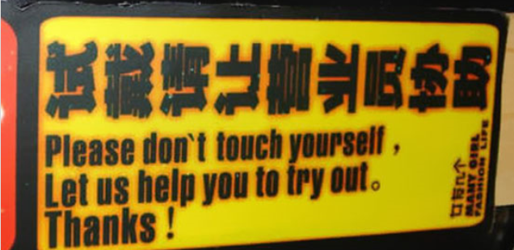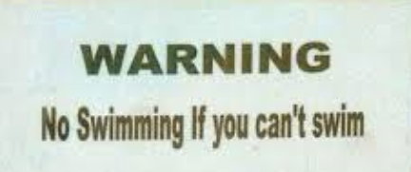





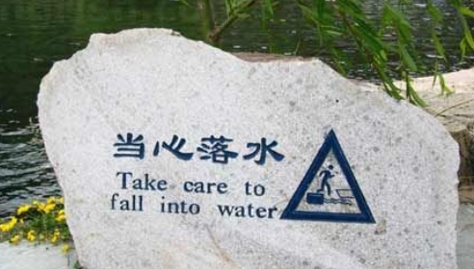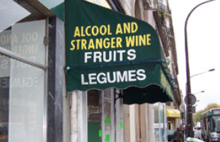

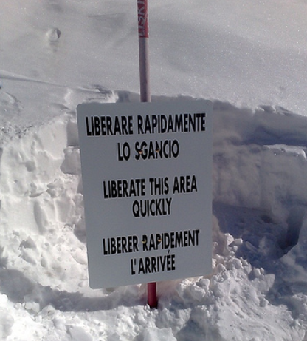 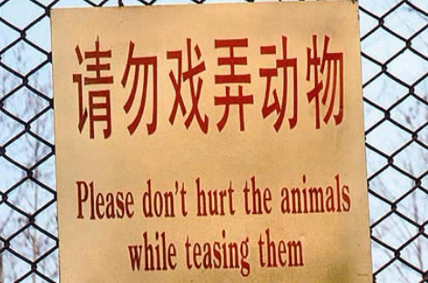

**FUNNY TRANSLATIONS INTO ENGLISH**

1. In a Tokyo Hotel:  
   Is forbidden to steal hotel towels please. If you are not a person to do such thing is please not to read notis.
2. In a Bucharest hotel lobby:  
   The lift is being fixed for the next day. During that time we regret that you will be unbearable.
3. In a Paris hotel elevator:  
   Please leave your values at the front desk.
4. In a hotel in Athens:  
   Visitors are expected to complain at the office between the hours of 9 and 11 a.m. daily.
5. In a Japanese hotel:  
   You are invited to take advantage of the chambermaid.
6. In the lobby of a Moscow hotel across from a Russian Orthodox monastery:  
   You are welcome to visit the cemetery where famous Russian and Soviet composers, artists, and writers are buried daily except Thursdays.
7. Outside a Hong Kong tailor shop:  
   Ladies may have a fit upstairs.
8. In a Bangkok dry cleaner's:  
   Drop your trousers here for best results.
9. Outside a Paris dress shop:  
   Dresses for street walking.
10. In a Rhodes tailor shop:  
    Order your summers suit. Because is big rush we will execute customers in strict rotation.
11. In a Czechoslovakian tourist agency:  
    Take one of our horse-driven city tours - we guarantee no miscarriages.
12. Advertisement for donkey rides in Thailand:  
    Would you like to ride on your own ass?
13. In a Bangkok temple:  
    It is forbidden to enter a woman even a foreigner if dressed as a man.
14. On the door of a Moscow hotel room:  
    If this is your first visit to the USSR, you are welcome to it.
15. In a Budapest zoo:  
    Please do not feed the animals. If you have any suitable food, give it to the guard on duty.
16. In an Acapulco hotel:  
    The manager has personally passed all the water served here.
17. Two signs from a Majorcan shop entrance:  
    - English well talking.  
    - Here speeching American.
18. In an East African newspaper:   
    A new swimming pool is rapidly taking shape since the contractors have thrown in the bulk of their workers.
19. Restaurant window:   
    Don't stand there and be hungry. Come on in and get fed up.
20. Sign at Mexican disco:   
    Members and non-members only.
21. Electrolux, a Scandinavian vacuum cleaner, used the following in the U.S.: “Nothing sucks like an Electrolux.”
22. Hotel, Yugoslavia:   
    THE FLATTENING OF UNDERWEAR WITH PLEASURE IS THE JOB OF THE CHAMBERMAID.
23. Hotel, Vienna:   
    IN CASE OF FIRE, DO YOUR UTMOST TO ALARM THE HOTEL PORTER.
24. Hotel brochure, Italy:   
    THIS HOTEL IS RENOWNED FOR ITS PEACE AND SOLITUDE. IN FACT, CROWDS FROM ALL OVER THE WORLD FLOCK HERE TO ENJOY ITS SOLITUDE.
25. In a City restaurant: OPEN SEVEN DAYS A WEEK, AND WEEKENDS TOO.
26. In a Nairobi restaurant:   
    CUSTOMERS WHO FIND OUR WAITRESSES RUDE OUGHT TO SEE THE MANAGER.
27. On the grounds of a private school:   
    NO TRESPASSING WITHOUT PERMISSION.
28. Tokyo hotel's rules and regulations:   
    GUESTS ARE REQUESTED NOT TO SMOKE OR DO OTHER DISGUSTING BEHAVIOURS IN BED.
29. Airline ticket office, Copenhagen:   
    WE TAKE YOUR BAGS AND SEND THEM IN ALL DIRECTIONS.
30. Cocktail lounge, Norway:   
    LADIES ARE REQUESTED NOT TO HAVE CHILDREN IN THE BAR.
31. Doctors office, Rome:   
    SPECIALIST IN WOMEN AND OTHER DISEASES.
32. Information booklet about using a hotel air conditioner, Japan:   
    COOLES AND HEATES: IF YOU WANT CONDITION OF WARM AIR IN YOUR ROOM,PLEASE CONTROL YOURSELF.
33. One of the Mathare buildings:   
    MENTAL HEALTH PREVENTION CENTRE.
34. In a Pumwani maternity ward:   
    NO CHILDREN ALLOWED.
35. On the menu of a Swiss restaurant:   
    OUR WINES LEAVE YOU NOTHING TO HOPE FOR.
36. A laundry in Rome:   
    LADIES, LEAVE YOUR CLOTHES HERE AND SPEND THE AFTERNOON HAVING A GOOD TIME.
37. In a Swiss mountain inn:   
    SPECIAL TODAY - NO ICE-CREAM.

Refleksija:

Dijakom je bila ta vaja zelo zabavna. Večinoma so prepoznali težave v prevodih in se zraven tudi nasmejali. Koristila jim je tudi pri razvijanju besedišča in slovničnih struktur, saj so morali poiskati sopomenke, razmišljati o tako imenovanih ’false friends’ in se strinjali, da vsi, ki se ukrvarjamo s tujimi jeziki, naletimo na podobne zagate.

Zbrala in pripravila: Mirjam Skube